**‹JavaScript – Tutorial**

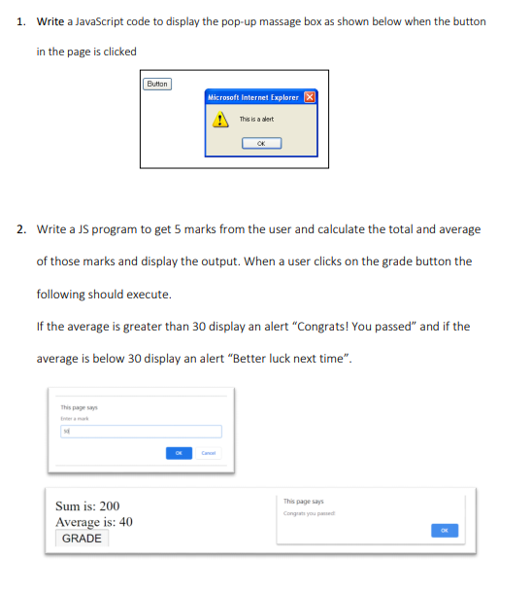

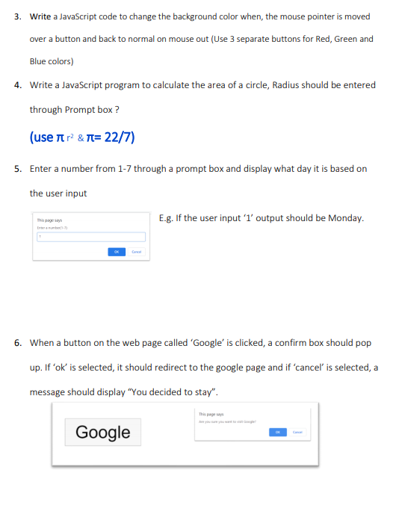

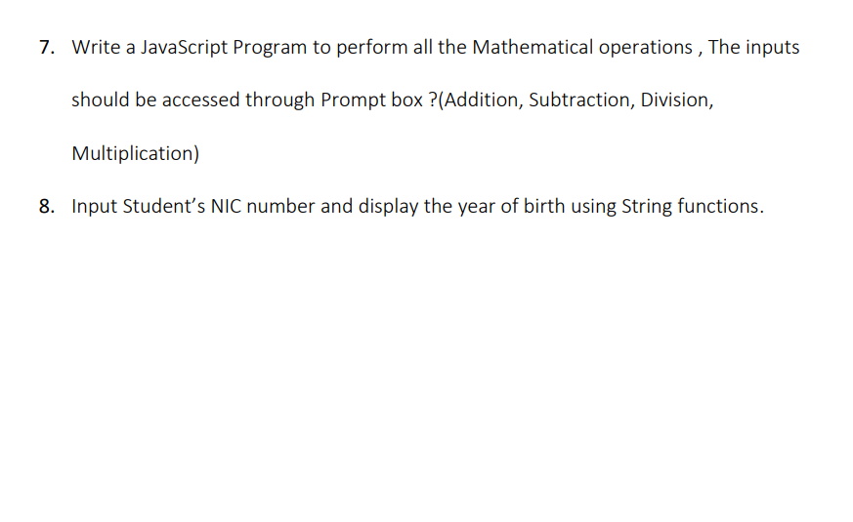**Answers**

function showMessage() {

var message = document.getElementById("message");

message.style.display = "block";

}

function closeMessage() {

var message = document.getElementById("message");

message.style.display = "none";

}

function getMarks() {

var marks = [];

for (var i = 0; i < 5; i++) {

var mark = parseInt(document.getElementById("mark" + i).value);

marks.push(mark);

}

return marks;

}

function calculateTotal() {

var marks = getMarks();

var total = 0;

for (var i = 0; i < marks.length; i++) {

total += marks[i];

}

document.getElementById("total").innerHTML = total;

}

function calculateAverage() {

var marks = getMarks();

var total = 0;

for (var i = 0; i < marks.length; i++) {

total += marks[i];

}

var average = total / marks.length;

document.getElementById("average").innerHTML = average;

}

document.getElementById("gradeButton").onclick = function() {

var marks = getMarks();

var total = 0;

for (var i = 0; i < marks.length; i++) {

total += marks[i];

}

var average = total / marks.length;

if (average >= 30) {

document.getElementById("grade").innerHTML = "Congrats! You passed";

} else {

document.getElementById("grade").innerHTML = "Better luck next time";

}

}

<!DOCTYPE html>

<html>

<head>

<style>

button {

padding: 10px 20px;

font-size: 16px;

cursor: pointer;

}

</style>

</head>

<body>

<button id="redButton" onmouseover="changeColor('red')" onmouseout="resetColor('red')">Red</button>

<button id="greenButton" onmouseover="changeColor('green')" onmouseout="resetColor('green')">Green</button>

<button id="blueButton" onmouseover="changeColor('blue')" onmouseout="resetColor('blue')">Blue</button>

<script>

function changeColor(color) {

document.getElementById(color + 'Button').style.backgroundColor = color;

}

function resetColor(color) {

document.getElementById(color + 'Button').style.backgroundColor = '';

}

</script>

</body>

</html>

<!DOCTYPE html>

<html>

<head>

</head>

<body>

<script>

function calculateCircleArea() {

const pi = 22 / 7;

const radius = parseFloat(prompt("Enter the radius of the circle:"));

if (!isNaN(radius)) {

const area = pi * radius * radius;

alert("The area of the circle is: " + area);

} else {

alert("Invalid input. Please enter a valid number for the radius.");

}

}

</script>

<button onclick="calculateCircleArea()">Calculate Area</button>

</body>

</html>

<!DOCTYPE html>

<html>

<head>

</head>

<body>

<script>

function getDayOfWeek() {

const userInput = parseInt(prompt("Enter a number from 1 to 7:"));

if (userInput >= 1 && userInput <= 7) {

const daysOfWeek = ["Sunday", "Monday", "Tuesday", "Wednesday", "Thursday", "Friday", "Saturday"];

const day = daysOfWeek[userInput - 1];

alert("The corresponding day of the week is: " + day);

} else {

alert("Invalid input. Please enter a number between 1 and 7.");

}

}

</script>

<button onclick="getDayOfWeek()">Get Day of the Week</button>

</body>

</html>

<!DOCTYPE html>

<html>

<head>

</head>

<body>

<button id="googleButton">Google</button>

<script>

document.getElementById("googleButton").addEventListener("click", function() {

const confirmation = confirm("Do you want to visit Google?");

if (confirmation) {

window.location.href = "https://www.google.com";

} else {

alert("You decided to stay.");

}

});

</script>

</body>

</html>

<!DOCTYPE html>

<html>

<head>

</head>

<body>

<script>

function performMathOperations() {

const num1 = parseFloat(prompt("Enter the first number:"));

const num2 = parseFloat(prompt("Enter the second number:"));

if (!isNaN(num1) && !isNaN(num2)) {

const addition = num1 + num2;

const subtraction = num1 - num2;

const multiplication = num1 * num2;

const division = num1 / num2;

alert("Addition: " + addition + "\nSubtraction: " + subtraction +

"\nMultiplication: " + multiplication + "\nDivision: " + division);

} else {

alert("Invalid input. Please enter valid numbers.");

}

}

</script>

<button onclick="performMathOperations()">Perform Math Operations</button>

</body>

</html>

<!DOCTYPE html>

<html>

<head>

<title>NIC Number Input</title>

<script>

function getYearOfBirth(nic) {

var yearOfBirth = nic.substring(0, 4);

return yearOfBirth;

}

function displayYearOfBirth() {

var nic = document.getElementById("nic").value;

var yearOfBirth = getYearOfBirth(nic);

document.getElementById("yearOfBirth").innerHTML = yearOfBirth;

}

</script>

</head>

<body>

<h1>NIC Number Input</h1>

<input type="text" id="nic" placeholder="Enter the NIC number">

<button onclick="displayYearOfBirth()">Display Year of Birth</button>

<p id="yearOfBirth"></p>

</body>

</html>